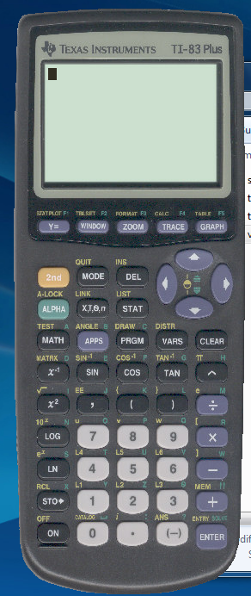
How to enter a matrix on your calculator:

From the ‘home’ screen: Press 2nd then Matrix. You should see:
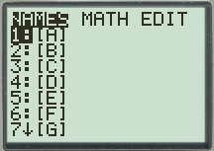
Then scroll over to edit (using the arrow keys)

Once in edit, select a matrix to edit – then you should see this:
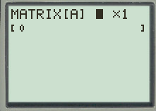
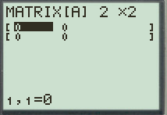
From here, you can change the dimensions, by selecting the number where you currently see the cursor (once that’s done, hit enter, and it will let you change the number of columns. )
As you can see – when you change the dimensions, it changes the actual size. You can enter your matrix values now by typing in the value and then hitting enter. When you are done, type 2nd then quit.

REPEAT AS NEEDED (using different matrices)

How to multiply matrices on your calculator:

Once you have enter the matrices into your calculator, you are going to hit 2nd then matrix again getting here:

Then you will select the first matrix you want to multiply (using [A] as an example) , hit enter and you should see:
You will type in a multiplication sign and then you will repeat the above step with the second matrix you want to multiply. See next pic:
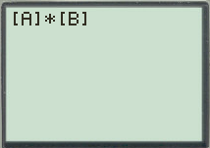
Hit enter, then you should get your solution… If you get a message that says “DIM MISMATCH” then you can’t multiply those matrices together because their dimensions don’t allow them to be multiplied.

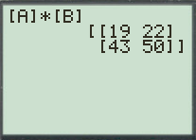 YAY! ( you can also use this method to add and subtract)

How to find the inverse of a matrix on your calculator:

Once you have enter the matrices into your calculator, you are going to hit 2nd then matrix again getting here:

Then you will select the first matrix you want to multiply (using [A] as an example) , hit enter and you should see:
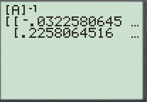
You will type the inverse sign (it looks like x⁻¹) and then you will hit enter.

your solution should look like this… to find the other values, just scroll to the left or right using the arrow keys.

How to find the determinant of a matrix on your calculator:

Once you have enter the matrices into your calculator, you are going to hit 2nd then matrix again getting here:
Then you will scroll over to MATH, seeing the screen below:

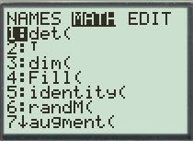
Then select the first option, det( by hitting enter.

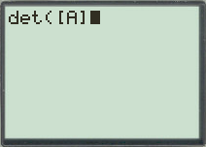
After you see this screen, you are going to hit 2nd then matrix again and then you will select the matrix you want to find the determinant of (using [A] as an example) , hit enter and you should see:
Hit enter, then you should get your solution…
